AI ASSISTED CODING:
ASSIGNMENT 9.3:
NAME: VAISHNAVI VARDINENI
HT NO:2403A51431
BATCH:16
TASK 1:
Write a python program to find addition of even and odd numbers from the list 1-10 without using docstrings and inline comments.
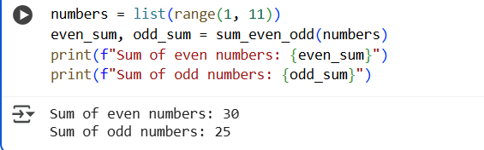
ADD DOC STRING:
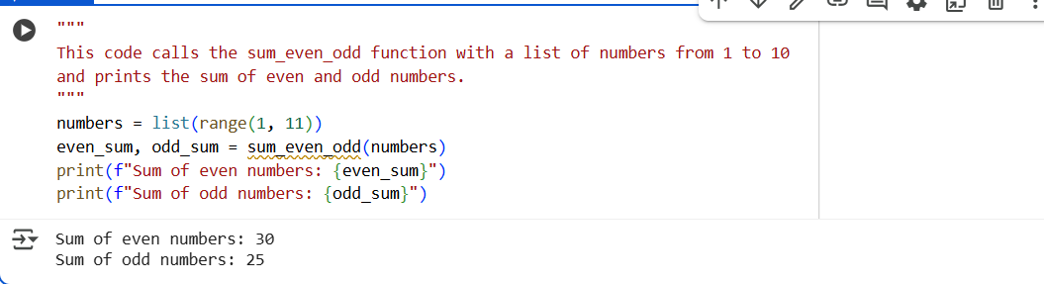

TASK 2:
Write python program for sru_student class with attributes like name, roll no., hostel_status and fee_update method and display_details method.
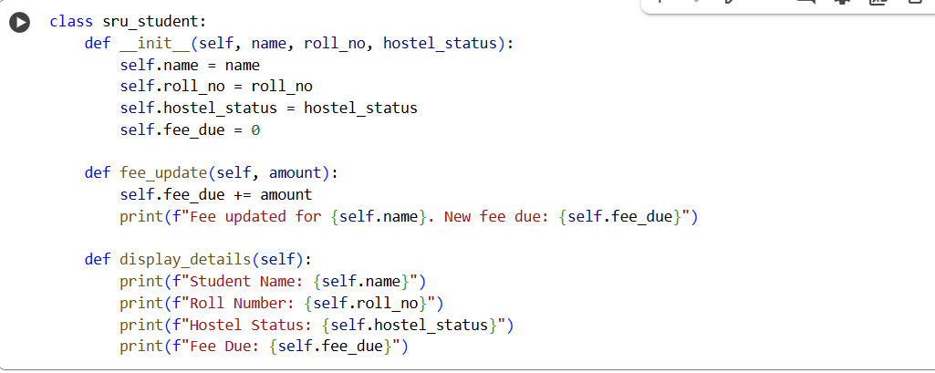
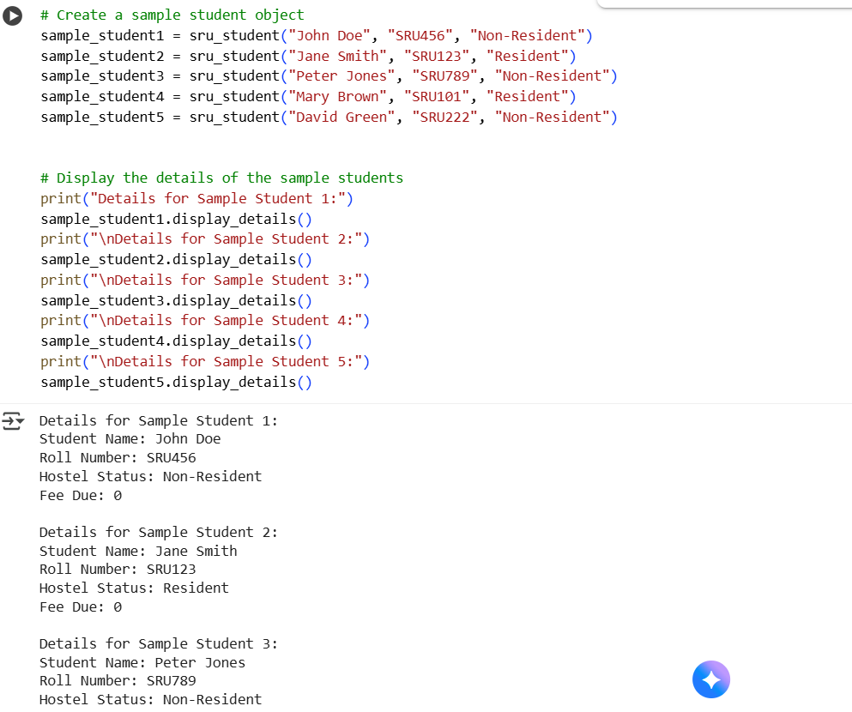
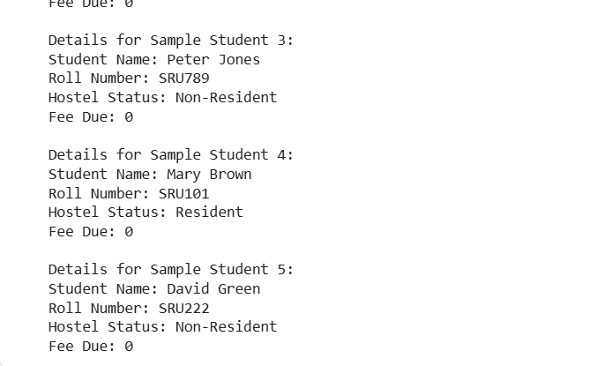
ADDING DOC STRING AND INLINE COMMENTS:
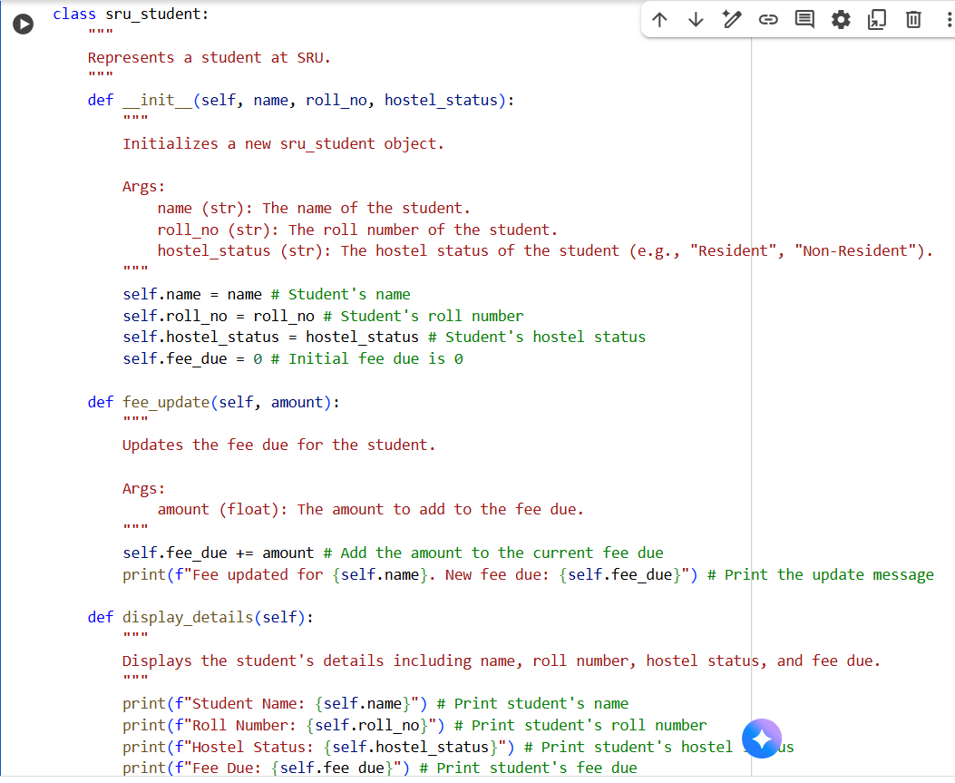
TASK 3:
Write a Python program with 3–4 functions (e.g., calculator: add, subtract, multiply, divide)
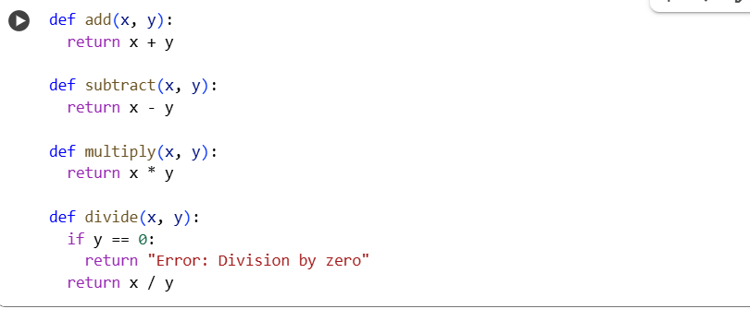
ADDING DOC STRING AND INLINE COMMENTS:
